**Lesson 3 Demo 1**

**Managing and** **Administering a Kubernetes Cluster**

**Objective:** Managing and administering a cluster to understand concepts such as verifying security certificates, creating namespaces, and accessing clusters using Kubernetes API

**Tools required:** kubeadm, kubectl, kubelet, and etcd

**Prerequisites:** A Kubernetes cluster must be set up (follow the steps in Lesson 1 Demo 1)

Steps to be followed:

1. Verify the certificates of the cluster
2. View the cluster information
3. Create a namespace
4. Access clusters using Kubernetes API

**Step 1: Verify the certificates of the cluster**

1. Check certificate’s expiration date as a regular user

*sudo kubeadm certs check-expiration*

**Step 2: View the cluster information**

1. Enter the following command in the master node:

*kubectl cluster-info*

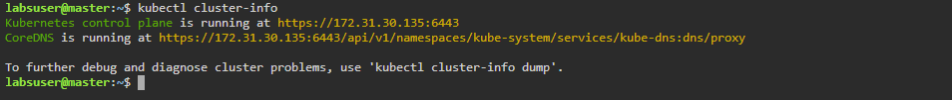

**Step 3: Create a namespace**

1. Use the following command to create a namespace:

k*ubectl create namespace firstnamespace*

￼￼

3.2 Verify the newly created namespace in the master node

*kubectl get* *namespaces -A*

1. View the cluster configuration using the following command:

*kubectl config view*

*kubectl proxy --port=8080*

4.3 Click on the **master** tab on the lab, and then click on the **desktop** option

4.4 Navigate to the **desktop** tab and open **Firefox** browser to access the **API server** by typing the IP address and port mentioned in step 4.2’s output

